**Name: Hussein Mohamed Elwakeel**

Q1:

String greeting ="Hello Dart";

void main() {

print(greeting);

}

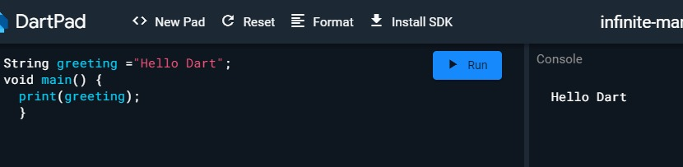

Q2:

const int a=5;

const int b=7;

void main() {

print("$a $b");

}

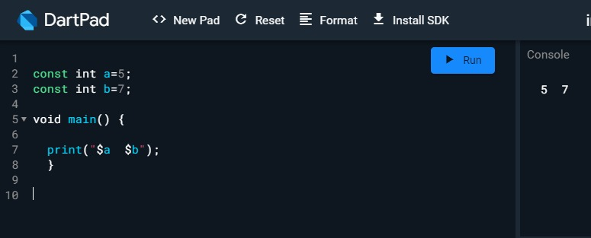

Q3:

void main() {

double celsiusTemperature = 25.0;

double fahrenheitTemperature = celsiusTemperature * 9.0 / 5.0 + 32.0;

print("$celsiusTemperature°C is $fahrenheitTemperature°F.");

fahrenheitTemperature = 77.0;

celsiusTemperature = (fahrenheitTemperature - 32.0) * 5.0 / 9.0;

print("$fahrenheitTemperature°F is $celsiusTemperature°C.");

}

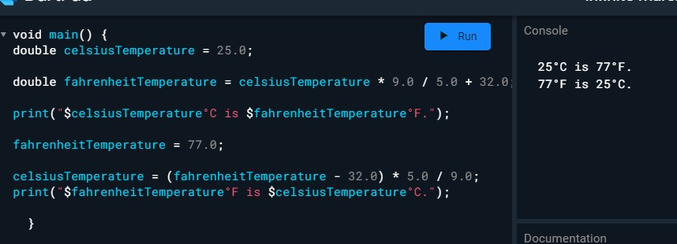

Q4:

void main() {

int birthYear = 2000;

int futureYear = 2026;

int ageInFutureYear = futureYear - birthYear;

print("I will be $ageInFutureYear in $futureYear.");

}

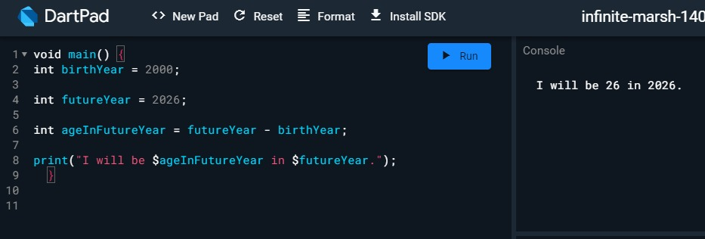

Q5:

void main() {

int a = 10;

int b = 20;

// Perform the arithmetic operations

int sum = a + b;

int difference = a - b;

int product = a * b;

double quotient = a / b;

// Print the results

print("Sum: $sum");

print("Difference: $difference");

print("Product: $product");

print("Quotient: $quotient");

}

